**CSCI 1411 – Lab 12–Objects with Classes**

**Goals:**

* Understand how to build and use Classes
* Understand how to use arrays of objects built with classes

**Development Environment:** (all students must use Clion)

**Skills:** Classes, Default Constructor, Constructor, member functions, arrays of objects.

**Reading**: Chap 13

**Deliverables:** 1) This lab with 3 screen shots 2) lastnameFirstLab12.cpp, Scores.h, Scores.cpp

**Part I – Skills Practice (5 points)**

* Open a new project in CLion. Call the project Lab12a.
* For this project we are reversing a CString and a string Right click on the Lab11a
* New->New C++ Class

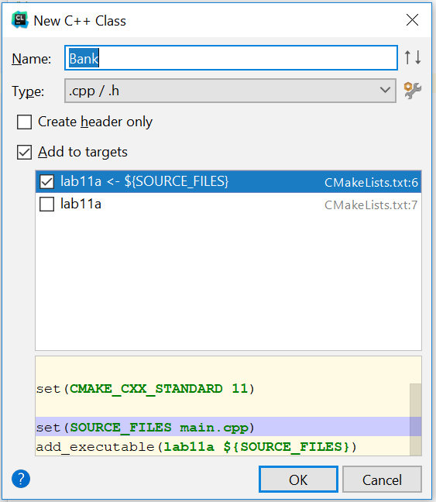

* Add the name Bank. And accept the defaults Add to targets and Lab11a<-$(Source_Files)
* This will create both a Bank.h file and a Bank.cpp file
* Double Click on the Bank.h file. Replace the entire text with this
* **#ifndef BANK_H  
  #define BANK_H  
    
  #include <string>  
  using namespace std;  
  class Bank  
  {  
  private:  
   string name;  
   int number;  
   float balance;  
  public:  
   Bank(); //default constructor  
   Bank(string _name, int _number, float _balance); //constructor**

**string getName(){return name;}  
 void setName(string _name){name=_name;}  
 int getNumber() {return number;}  
 void setNumber(int _number){number = _number;}  
 float getBalance(){return balance;}  
 void increaseBalance(float amount);  
};  
#endif**

* Now double click on the Bank.cpp. Replace the entire code with the code below:

**#include "Bank.h"  
Bank::Bank()   
{  
 name = "";  
 number = 0;  
 balance = 0;  
}  
  
Bank::Bank(string _name, int _number, float _balance)  
{  
 name = _name;  
 number = _number;  
 balance = _balance;  
}  
  
void Bank::increaseBalance(float amount)   
{  
 balance = balance + amount;  
}**

* Now double click on the main.cpp. Replace the entire code with the code below:

**#include <iostream>  
#include "Bank.h"  
using namespace std;  
int main()  
{  
 Bank acct1("Name", 123, 12.50);  
  
 cout << acct1.getName() << endl;  
 cout << acct1.getNumber()<<endl;  
 cout << acct1.getBalance()<<endl;  
 acct1.increaseBalance(200.00);  
 cout << acct1.getName() << endl;  
 cout << acct1.getNumber()<<endl;  
 cout << acct1.getBalance()<<endl;  
 return 0;  
}**

* Now if you did everything correctly it should compile. If it has errors, try to fix the errors by reading the error and clicking on the link to the error.
* Once it successfully compiles, go to Run->Run Lab 12a
* Take a **screenshot** of the successful output below:
* Go to Run->View Breakpoints
* Check on the main.cpp breakpoint and hit the red minus sign to delete the breakpoint.

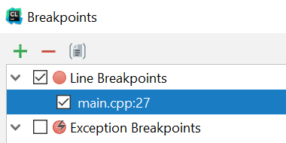

* Some of the things that you should have noted in this example.
  + Classes should start with a capital letter.
  + The Class declaration should be in the .h file
  + The Class definitions should either be in line (in the .h file) if only one line, or in a separate .cpp file
  + The .h file should always start with the #ifndef, #define and end with the #endif. This ensures that code is only defined once in a compilation
  + Every class should have a default constructor. This is called whenever an object of that type is declared. The default constructor usually initializes the private variables
  + Any public member function can directly access the private variables.

**Part II – More Skills Practice (5 points)**

Arrays of Classes. We will now create an array of Bank Accounts

Using the code from Part I. Change main.cpp to:

**#include <iostream>  
#include "Bank.h"  
using namespace std;  
int main()  
{  
 const int SIZE = 2;  
 string tempName;  
 int tempNumber;  
 float tempBalance;  
  
 Bank acctArray[SIZE];  
 for (int i=0; i<SIZE; i++)  
 {  
 cout << "Name for customer " << i+1 <<endl;  
 getline(cin,tempName);  
 cout << "Number for customer " << i+1 <<endl;  
 cin >> tempNumber;  
 cout <<"Balance for customer " << i+1 <<endl;  
 cin >> tempBalance;  
 cin.ignore(); *//removes '/n' in buffer for next getline* cout <<endl;  
 acctArray[i].setName(tempName);  
 acctArray[i].setNumber(tempNumber);  
 acctArray[i].increaseBalance(tempBalance);  
  
 }  
  
 for (int i=0; i<SIZE; i++)  
 {  
 cout << acctArray[i].getName() << endl;  
 cout << acctArray[i].getNumber()<<endl;  
 cout << acctArray[i].getBalance()<<endl<<endl;  
 }  
 return 0;  
}**

* Set a breakpoint at the return 0;
* Run->Debug 12a
* Add two users information.
* Take a **screenshot** of the output and place it below: